LOCATION: CONTACT:
NWNW, NENW, SENW, SWNE Sec. 33 R.J. Wickham, DNR Forester
Town of Richford, Waushara County 427 E. Tower Dr. Suite 100
Wautoma, WI 54982
920-787-4686 ext. 3023
ESTIMATED VOLUME:
SPECIES SAWTIMBER CORDS (see cover letter for weight conversions)
Black Oak 8,100 BF 60
White Oak 1,000 see black oak
Red Pine 45
White Pine 10
Jack Pine 60
Mixed Hardwood 3,800 15
(ash, cherry, birch, maple)
Aspen 40
Locust 115
TOTAL 12,900 Board Feet 345 Cords

CUTTING REQUIREMENTS:
Oak, Jack Pine, &Aspen Harvest (13 acres) – Cut ALL stems greater than 1-inch in diameter within the Red paint line except do not cut trees marked in Green paint and do nut cut any white pine and red pine.
Red Pine & White Pine Thinning (5 acres) – Cut ALL stems marked in Orange Paint and ALL Jack pine and Scotch pine within the plantation.
Locust Removal (6 acres) – Cut ALL stems greater than 1-inch in diameter within the Red paint line except do not cut trees marked in Green paint and all white pine and spruce unless marked with orange paint. All locust stumps must be treated with an herbicide approved by the DNR forester to prevent stump sprouting. A marker dye must also be mixed with the approved herbicide.
ALL AREAS
- All Conifer stumps and horizontal wounds must be treated with a fungicide to prevent Annosum by the end of each day of cutting.
- No cutting or skidding will be allowed from April 1st - October 1st to prevent the spread of Oak Wilt.
- Damage to residual trees and advanced regeneration will not be tolerated.
- All pine products cut from June 1 to September 1 must be hauled within 3 weeks.
- Landings and main skid trails must be approved by the DNR Forester and/or Property Manager.
- Ground must be dry or frozen.
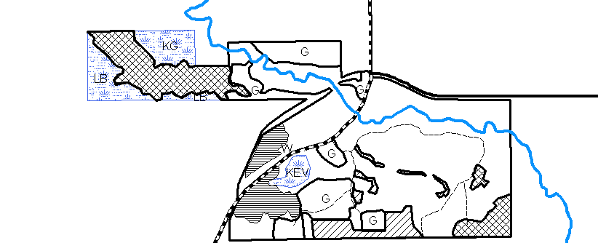
BIDDING REQUIREMENTS:
Please submit bid form (2400-049) and a 10% bid bond by 9:00 AM on Thursday December 16, 2010 to the contact listed above. Contract length shall be 2 years. Payment based on Mill Scale with Ticket System.

S. Branch Wedde Creek

Scale: 1” equals 660’

