Scott Walker, Governor
Cathy Stepp, Secretary
Jean Romback-Bartels, Acting Regional Dir.
Telephone 920-787-4686 ext. 3023
FAX 920-787-2477
richard.wickham@wisconsin.gov
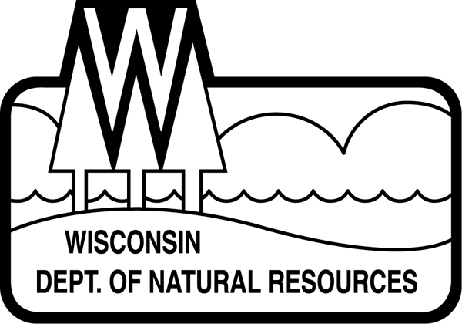State of Wisconsin
DEPARTMENT OF NATURAL RESOURCES
427 E. Tower Dr. Suite 100
Wautoma WI 54982

STUMPAGE FOR SALE – STATE OF WISCONSIN DNR
INVITATION FOR BIDS

You are invited to bid on the enclosed State of Wisconsin DNR and Private Timber Sales located in Marquette and Waushara Counties. Sealed bids for the timber sales will be received at the Wautoma DNR Service Center, 427 E. Tower Dr. Suite 100, Wautoma, WI 54982, prior to:
9:00 A.M. Thursday December 16, 2010

No bids will be accepted past 9:00 A.M. on December 16 2010 and bids will be opened immediately thereafter at the Wautoma Service Center.
Bidding Procedure:
- A bid bond of ten percent (10%) of the total bid value must accompany the bid for each sale. The bid bond shall be applied as an advanced stumpage payment for the successful bidder. In the event that the selected bidder refuses to sign a contract, the bid bond will be forfeited by the bidder. The bid bond may be cash, certified, or personal check.
- All state timber sale bids must be submitted on the enclosed bid forms for each timber sale. Contractors desiring to bid on more than one tract must submit separate bids and bid bonds for each tract. “Timber Sale SEALED BID” with Sale Name must be written on the outside of each separate envelope. Make checks payable to the Wisconsin DNR. The Department of Natural Resources and private landowners reserve the right to reject ANY and/or ALL bids.
- All bids for the 2 private land timber sales should follow bidding instructions on the prospectus.
- There is no guarantee of the quality or quantity of the wood products or volumes, therefore, bidders are encouraged to inspect each timber sales prior to bidding.

The following items are common to all sales and important to both the bidding process and successful contract compliance:
- A performance bond in the amount per each timber sale prospectus is required at contract signing.
- Contract extension, if granted, will be for one-time period only with the stumpage price increased by 10%.
- Sale methods will be by “mill scale” in conjunction with “haul” ticket system. Wood products delivered to private individuals (i.e. firewood) must have the copy of “haul” ticket returned to either the Wautoma or Montello Forestry Office (depending on the county the sale is located in).
- Mixed loads of species and/or wood products, that have different stumpage values, will be charged at the higher dollar value.
- Cordwood Weight Conversion Factors are as follows:
Red Pine: 4,500 lbs/cord Oak: 5,500 lbs/cord
White Pine: 4,200 lbs/cord Aspen 4,500 lbs/cord
Jack Pine: 4,250 lbs/cord Mixed Hardwood: 4,800 lbs/cord
Spruce: 4,000 lbs/cord Basswood: 3,850 lbs/cord
Oak Fuelwood: 5,350 lbs/cord Locust 5,300 lbs/cord
If needed, these conversion factors will be used to convert weight scale to standard 128 cubic foot cord.
- The Seller will be paid by the same method as the contractor is being paid by the mill. (i.e. product weight, stick scale, board feet) DNR product conversion weight factors will be utilized on all sales. If firewood is sold to private individuals, processed firewood will be weighed and “weight conversion factors” will be used to determine scale. Any 100-inch stick of firewood will be scaled by a representative of the Wisconsin DNR to determine scale.
- The following Product Conversion will be used:
-Softwood (red pine, white pine, jack pine, spruce): 1 MBF = 2.44 cords
-Hardwoods (oak, maple, birch, aspen, basswood): 1 MBF = 2.20 cords
- Proof of Worker’s Compensation Insurance required.
- Logging Contractor must document compliance with Wisconsin SFI and FSC training standards.
- Take note of the different cutting periods, restrictions, slash treatments, road restoration, decking areas, and harvesting requirements for each timber sale.
- Contracts may not be assigned.
- Other items as specified in the contract. Timber sale contracts are available upon request.

Heterobasidion Annosum (Annosum) Prevention Treatment
Treatment for reducing the risk of Annosum is required by the purchaser for all sales containing conifers. Purchaser will enter the timber sale area with equipment clean of soil.

Purchaser will apply an *approved wood preservative (fungicide) to all fresh cut conifer stumps and horizontal surfaces by the end of each day of cutting as follows:
- Pesticide applicators must be certified by DATCP for this treatment.
- All stumps will be left clear of logging slash.
- If Cellu-treat is used, a marker dye shall be added.
- Extra care must be taken to minimize damage to residual trees.
- All harvesting equipment must be cleaned of soil prior to leaving timber sale.

Approved Wood Preservatives
Label Name | Active Ingredient | Distributor
Sporax | Sodium Tetraborate | Wilbur-Ellis Company  1214 Cty Rd D, Almond, WI 715-366-2500  1-800-426-3491 www.wilbur-ellis.com
Cellu-Treat | Disodium Octaborate Tetrahydate | CPS Timberland  N5853 5th Ave Plainfield, WI 54966  715-335-4900 www.cps.com

Please contact the DNR Forester identified on each timber sale prospectus for more information.

Thank you for your interest in these timber sales. Please bid responsibly.

